**Department of Artificial Intelligence**

**College of Computer Science and Information Technology**

***Introduction to Figma Design***

1. **Objectives**

This lab introduces the basics of Figma design while emphasizing HCI principles. By the end of this lab, students will:

* Understand the process of creating wireframes and mockups using Figma.
* Apply HCI principles like usability, visual hierarchy, and user-centered design to interface designs.

**Lab Requirements**

Software: Software: Figma (Free Online Tool: [Figma.com](https://figma.com))

1. **Explanation of Key Concepts**

*  **Figma:**

A cloud-based tool for designing and collaborating on web and mobile interfaces.

**Some Features:**

* **Frames:** Artboards where layouts are designed.
* **Components:** Reusable design elements like buttons or icons.
* **Prototyping:** Link screens to simulate user interactions.

* **Wireframe:**

A basic layout that outlines the structure of a website or app, without focusing on visual details.

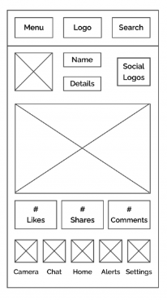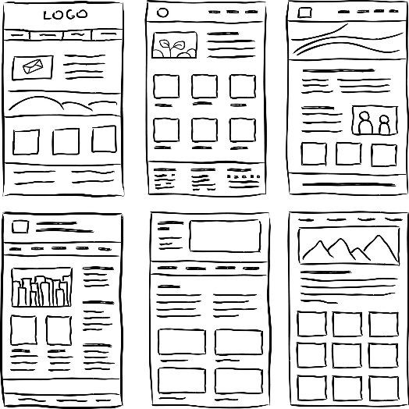

* **Mockup:**A detailed visual representation of a final design, including colors, typography, and spacing.



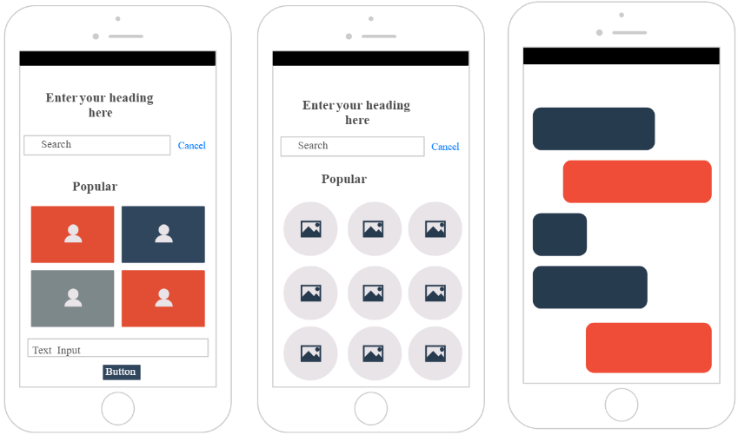

**Example:**

* + **Wireframe:**A basic layout for the LG login page with placeholders for the email and password fields, along with a "Login" button. No styling, just structure.
  + **Mock-up:**The wireframe is enhanced with colors, fonts, and brand styling, showing the final look of the LG login page**.**

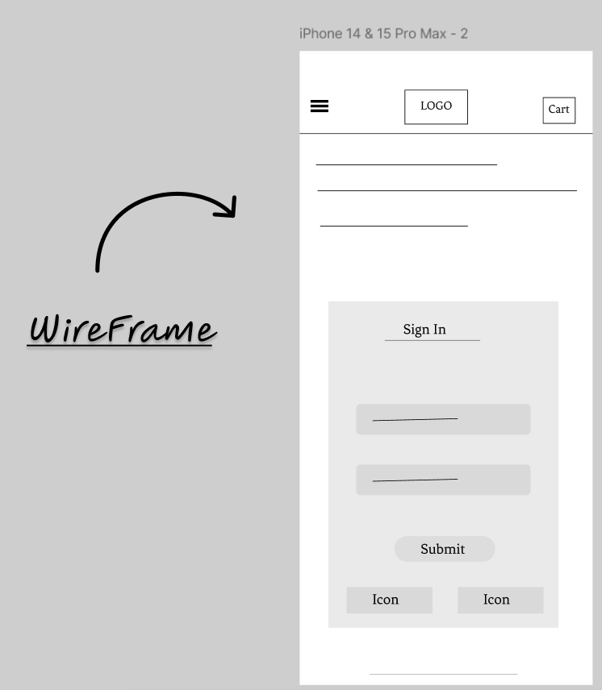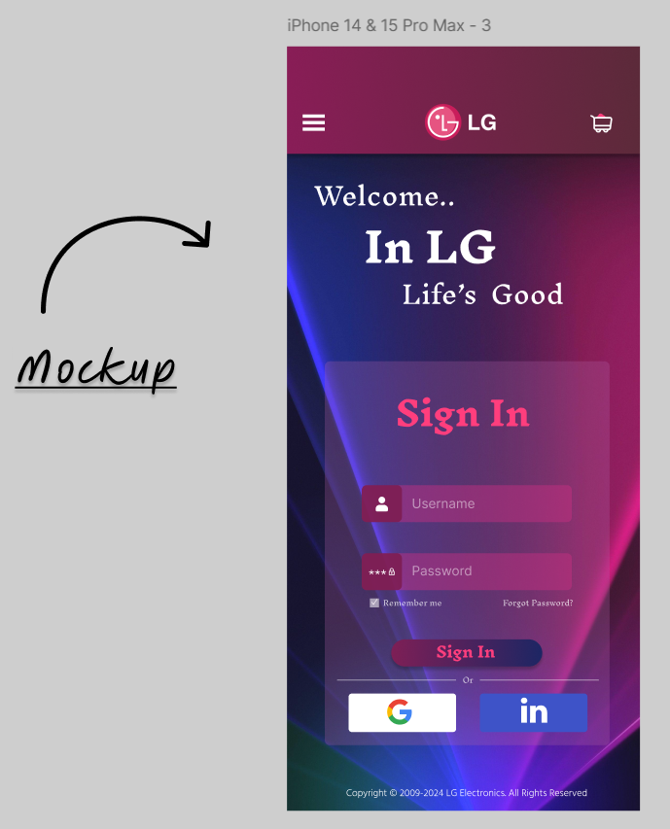



1. **Activities**

* **Exercise 1: Online Course Enrollment Page**

**Task 1**:

Create a wireframe for an Online Course Enrollment Page that is user-friendly and visually appealing. Use your creativity to design a layout that effectively communicates the purpose of the page.

Step 1: Create a new design file and name it “Lab 4 – Your ID”

Step 2: Create your first frame (artboard) Select the frame tool (F) and create a frame for a mobile screen (use iPhone 14 & 15 Pro Max size).

Step 3: Set the name of the frame to “Wireframe”

Step 4: Design Your Wireframe

**Choose Your Structure**:

* You have the freedom to design the layout and structure of the page as you see fit.
* Consider how users will navigate and interact with the page.
* Feel free to explore different layouts, styles, and arrangements.
* Think about how to organize information clearly and attractively.

Step 5:Focus on Layout and Spacing

* Ensure that all elements are well-aligned and spaced.
* Use placeholder text and shapes to keep the design clear and easy to follow.

**Task: 2**

Create a mockup for the Online Course Enrollment Page that reflects a visually appealing and user-friendly design. Your mockup should build upon the wireframe created in

Task 1 and provide a realistic representation of the final product.

Step 1: Create another mobile frame using the iPhone 14 & 15 Pro Max size to match the previous frame. Make the position this frame next to the wireframe and rename it to “Mockup.”

Step 2: Design Your Mockup

1. Build Upon Your Wireframe:
   * Use the wireframe created in Exercise 1 as a foundation for your mockup.
   * Add colors, typography, and images to enhance the visual appeal.
   * Ensure that the design reflects a realistic representation of the final product.
2. Add Visual Elements:
   * Incorporate icons, buttons, and images that align with your design theme.
   * Consider the use of color schemes that enhance readability and engagement.

Step3: Focus on Details and Aesthetics

* Pay attention to the overall aesthetics, ensuring that all elements are visually cohesive.
* Ensure that spacing, alignment, and color contrast are well-considered.
* **Exercise 2: Course Details Page**

**Task: 3**

Create a second page for the same project, focusing on a Course Details Page that provides users with detailed information about the course they are interested in. Use the same style and structure from the previous pages for consistency, but add new elements that make this page informative and engaging.

Step 1: Design both the wireframe and mockup for the Course Details Page. Ensure the design includes key information like the course title, description, instructor details, start date, and a call-to-action button. Add any additional elements that enhance the user experience.

1. **Submission**

After finish you must share the link of the Figma file follow the steps figures below:

1. 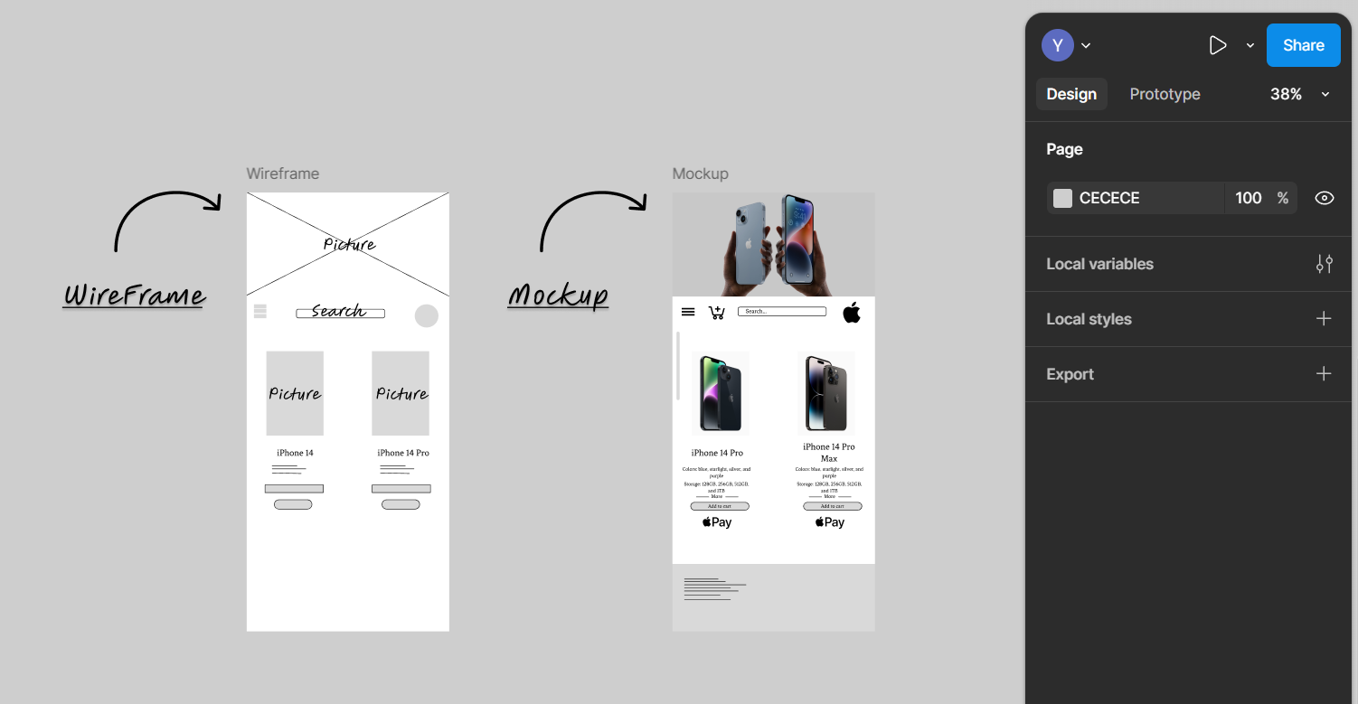**Click on share**
2. **Copy the link**

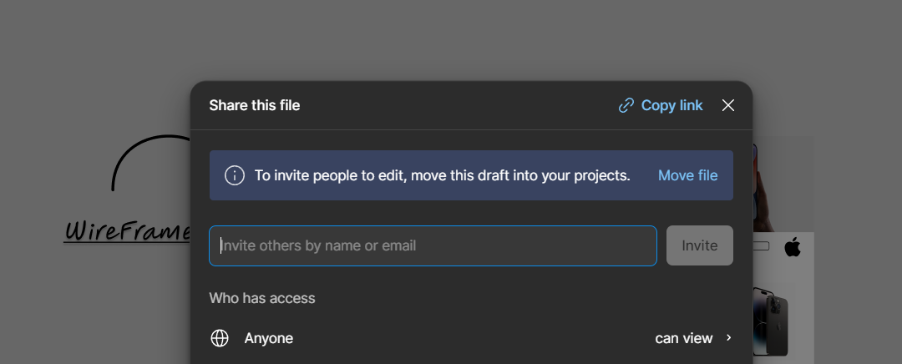



**Add Your Figma Link Here:** [**https://www.figma.com/design/UdjFjsCtJm7qmVV12KqZIR/Lab4--4220056-waziri-hci?node-id=0-1&t=ZDZ5suqTMSlprax7-1**](https://www.figma.com/design/UdjFjsCtJm7qmVV12KqZIR/Lab4--4220056-waziri-hci?node-id=0-1&t=ZDZ5suqTMSlprax7-1)

1. **References**

[**Get started – Figma Learn - Help Center**](https://help.figma.com/hc/en-us/categories/360002051613-Getting-Started)

Figma Wireframe Tutorial: [**https://www.youtube.com/watch?v=Iz-_cN2y0vA**](https://www.youtube.com/watch?v=Iz-_cN2y0vA)

Figma Mockup Tutorial: [**https://www.youtube.com/watch?v=DB29WvWJ-qM**](https://www.youtube.com/watch?v=DB29WvWJ-qM)